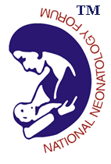

Facility Based Newborn Care Training Program at Raipur

The Government of India is committed to improve the newborn health care and bring a significant decline in the neonatal and infant mortality to meet the Sustainable Development Goals. The Government is planning to operationalize the primary health centers for round the clock deliveries and upgrade the health facilities at the district hospitals and referral centers in terms of inpatient neonatal care.
In this regard, the state of Chhattisgarh has taken a lead and has planned the Facility Based Newborn Care Training programat Raipur with training support from National Neonatology Forum.

Following are the tentative dates for the FBNC training at Raipur:

1. Batch A – 25th February to 28th February, 2020
2. Batch B– 2nd March to 5th March

Note: NNF FBNC faculty is requested to confirm participation as faculty for any one of the above mentioned date on secnnf@nnfi.org&accreditation@nnfi.org latest by 7th Feb. 2020.

Thanks & Regards
Dr. Lalan Kr. Bharti
Secretary General, NNF

